MANIFESTO BOOKLET
p
Positions

President

Silvia Epure

Manifesto not submitted by candidate

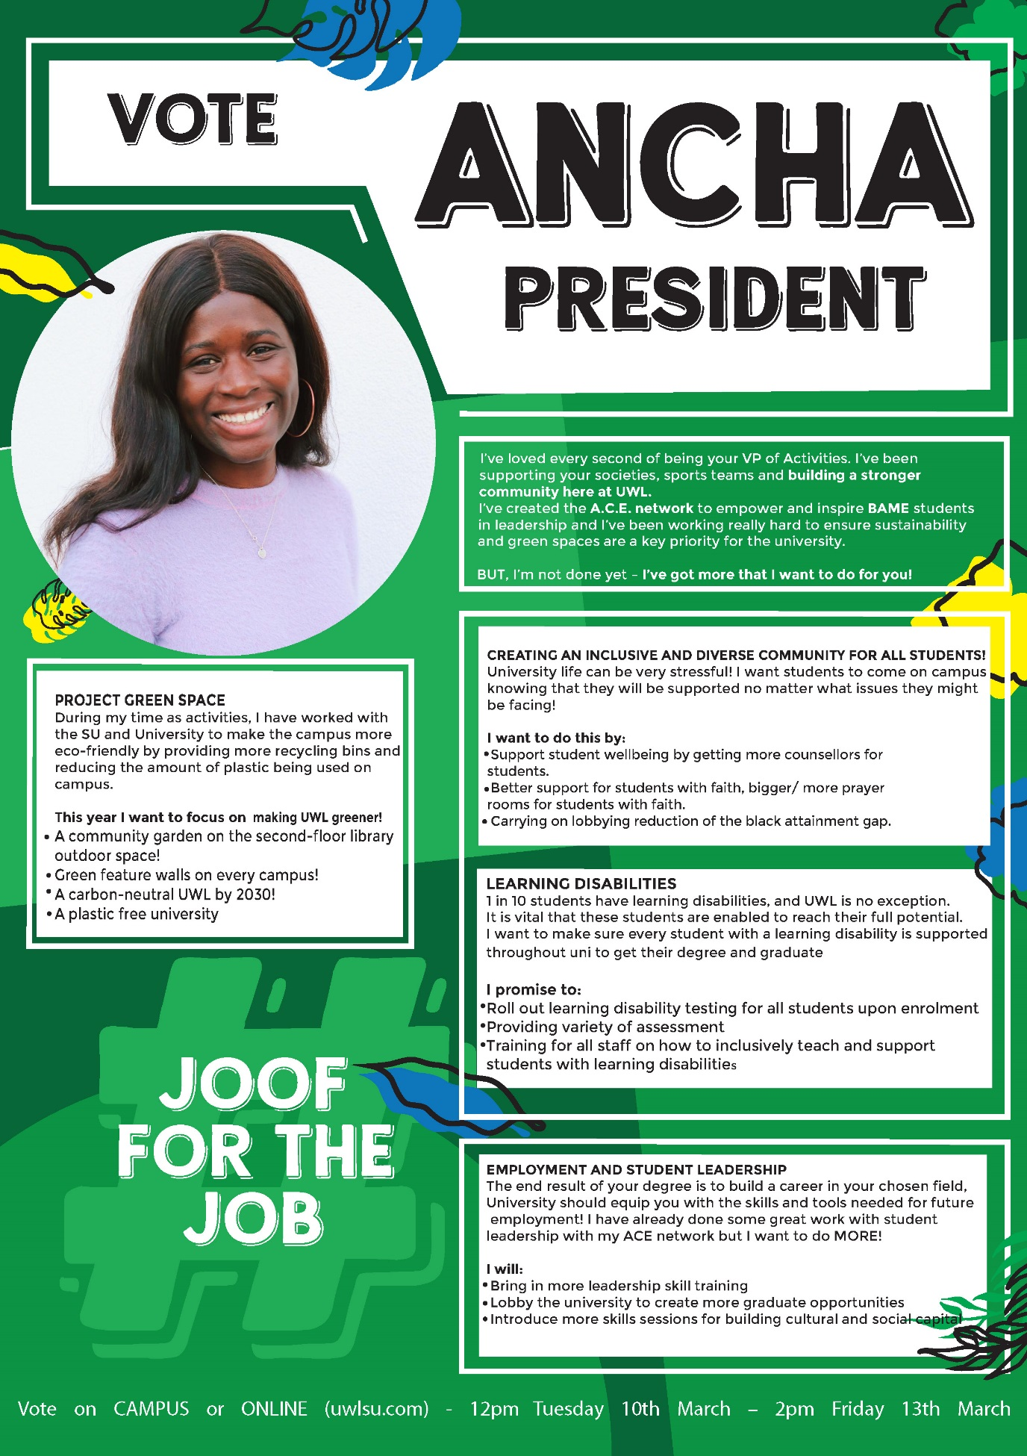
Ancha Joof
George Howes
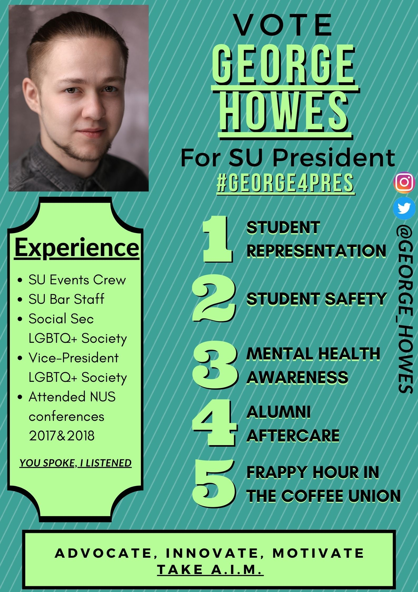

Vice President of Activities and Participation

Trushika Patel

Manifesto not submitted by candidate

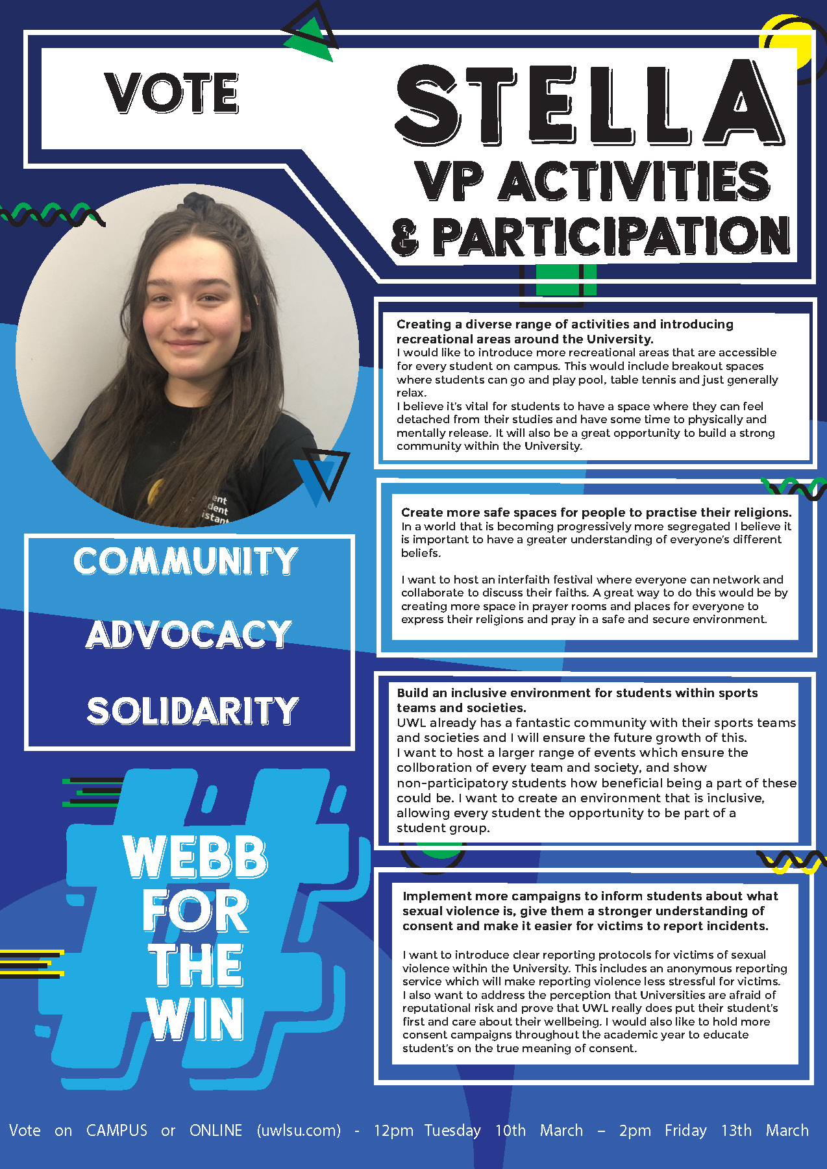
Stella Leonie Webb
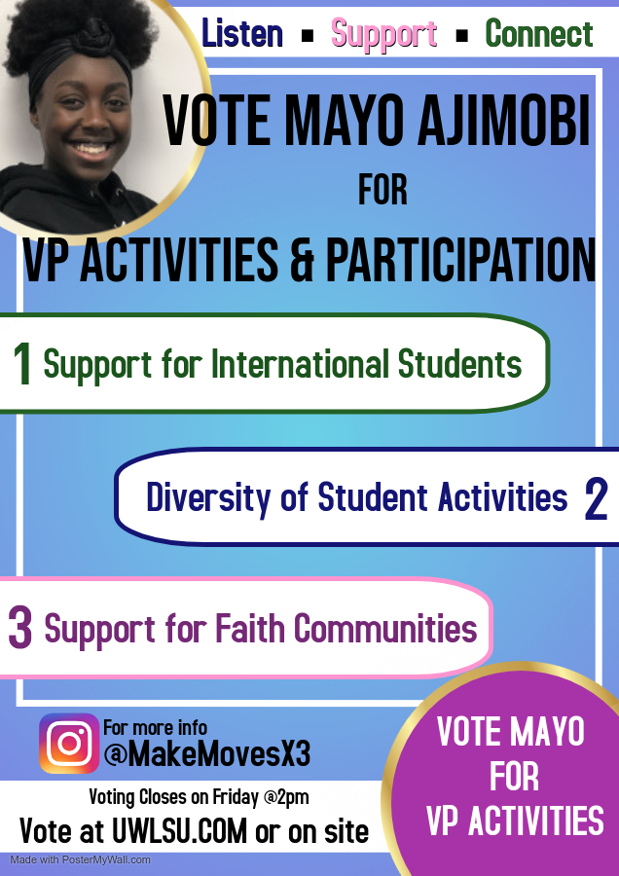
Mayo Ajimobi

Vice President of Education

Alessio Di Vito
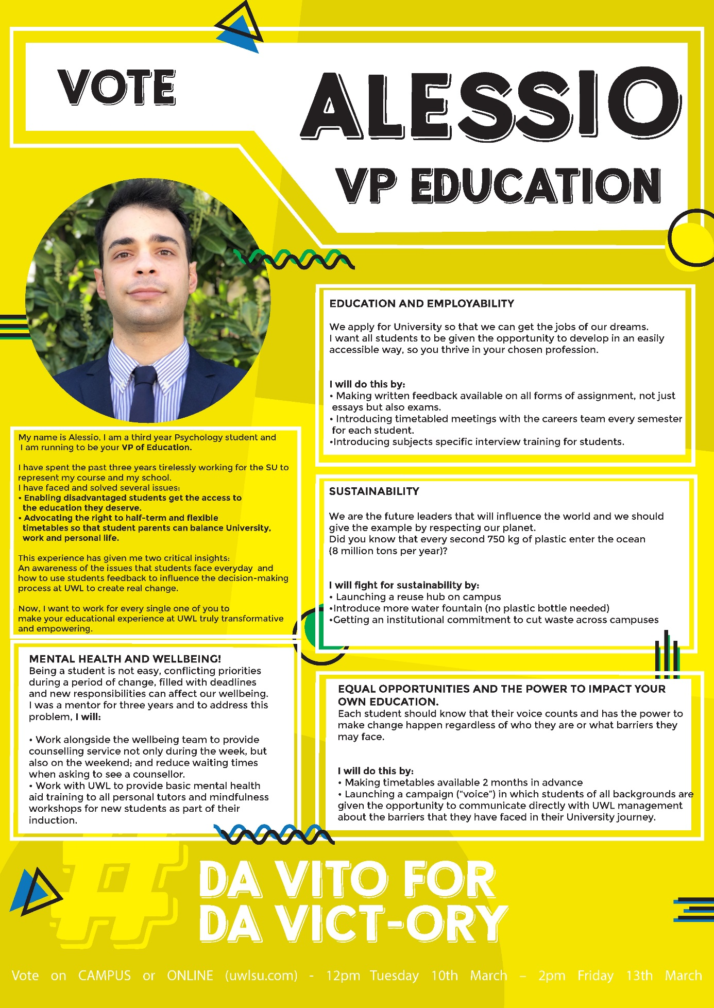
Ionela Cristina Hutanu

Manifesto not submitted by candidate

Aisha Stanuel-Taitte
